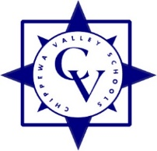

Chippewa Valley Schools
Curriculum Sub-Committee Meeting Minutes

Date: Monday, March 3, 2025 Meeting started at: 5:33 pm

Present: Denise Aquino, Monica Radyko, Robert Wojtowicz

Also Present: Don Brosky, Marina Licari, Ron Roberts
Additional Present: Kim Adlam, Sarah Monnier-White, Gabi Castillo (Curricular Leader)

Brief description of agenda items and discussion

- Overview of Elementary Reading Series Pilot Process:
- Timeline
- Current Reading Program adopted in 2017 is being phased out by the publisher
- MDE Grant will fund new adoption
- Two Programs selected by teachers to pilot
- 49 teachers representing every grade at all elementary schools have piloted
- Pilot teachers will recommend program for adoption for 2025-2026 school year
- Recommended reading series presented at April K-12 Evaluation Committee meeting
- Motion to adopt at April 7, 2025 Board of Education meeting

- Questions from Curriculum Sub-Committee

Meeting Adjourned at : 5:54 pm

Respectfully Submitted,
Donald Brosky

