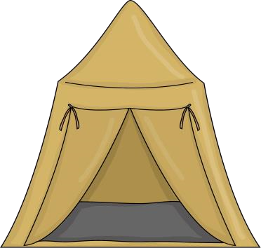
Classroom Supplies List

for

Mrs. Bock’s Class

2025

-

2026

1
Backpack

Lunch bag
1

1
Reusable water bottle

3

Boxes of Kleenex

1
Bottles of hand soap

3
Box of Crayola crayons
–

24
count

3
Containers of Play Doh

Package of Crayola Markers
1

1
Pack of erasers

100
Elmer glue sticks

1
Pair of scissors (loop scissors or spring
-
loaded scissors)

1
1inch 3 Ring binder with view pocket in front

1
Packet of top loading sheet/paper protectors

)
4
Containers of Lysol Disinfecting Wipes (all scents

3
Bags of Individual wrapped candy

2
Pencil boxes to keep supplies in the desk

1
Change of clothes in case of an accident

Diapers/Pull
-
ups and Wipes if needed

Donation of $20.00 (Cooking and Holiday craft projects)

Thank you,

Mrs. Bock

