School Bus Danger Zones

Did you know there are areas to stay clear of when getting on and off the bus?
Because school buses are so large, there are blind spots around the bus where it can be hard to see small children as they are preparing to board or after exiting a bus. Parents can help bus drivers keep children safe by discussing the danger zones depicted below.

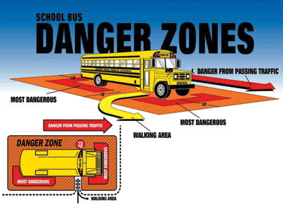

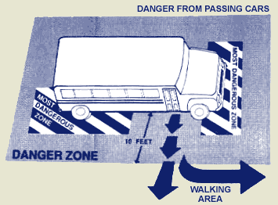
There are blind spots where the bus driver can lose sight of a child:
- Front Danger Zone: It is never safe to walk close to the front of the bus. Children should walk five giant steps ahead of the bus before. The children must wait for the driver’s directions to cross in front of the bus.
- Side Danger Zone: Children should always stay three giant steps away from the side of the bus.
- Rear Danger Zone: Never walk behind the school bus.
  - Walk (don’t run) three giant steps away from the bus when exiting the bus.

Getting On and Off the Bus
- Never run to catch the bus.
- If you have to walk on roads where there is no sidewalk, walk against traffic and out of the road.
- Stay out of the road and wait for the bus to stop before you walk to it.
- When the bus approaches, stay at least three giant steps away from the curb, remain on the sidewalk and wait until the driver gives directions to enter the bus.

- Make sure you can see the bus driver’s eyes when boarding the bus.

- When the student is in the “danger zone” around the bus they need to pay attention to the driver’s directions. The driver has a better view of oncoming traffic and will verbalize to the student when it is safe to cross the street.

- Use the handrail when you enter or exit the bus.

- Make sure there are no dangling pieces of clothing, drawstrings on hoods, untied shoestrings, key chains or backpack straps that could get caught on the handrail or in the bus door.

- If you drop something under or near the bus, do not pick it up until you tell the bus driver. Otherwise, the driver may not see you.

- If you leave something on the bus, don’t run after the bus to get it.

