In addition to finding your child’s Bus Stop Information on the ParentPortal, you can now access information on eLink, which is tied directly to our VersaTrans Routing and Planning software.
In order to access the information you will use your child’s Student ID # as both the User Name and the Password. The Student ID # is on your child’s schedule and their ID badge as well.
Log in using the following link - https://vtweb.tylertech.com/Chippewa/elinkrp/Login.aspx
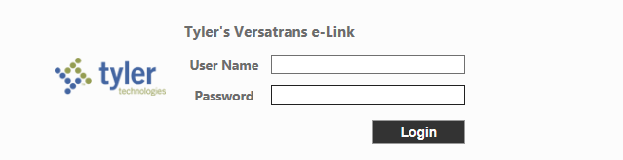
Your child’s Student ID is both the User Name and Password

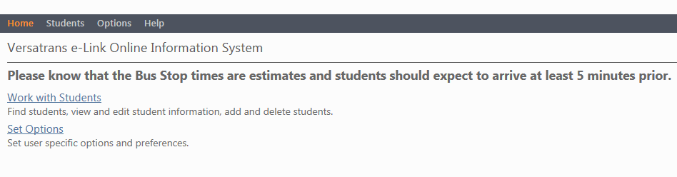
Choose ‘Work with Students
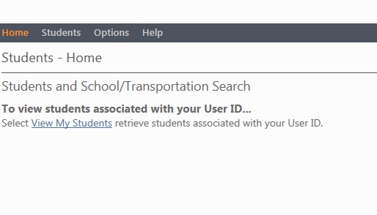
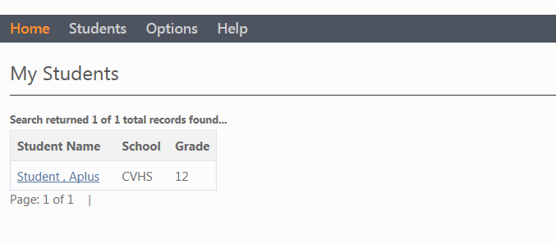
Select your child’s name

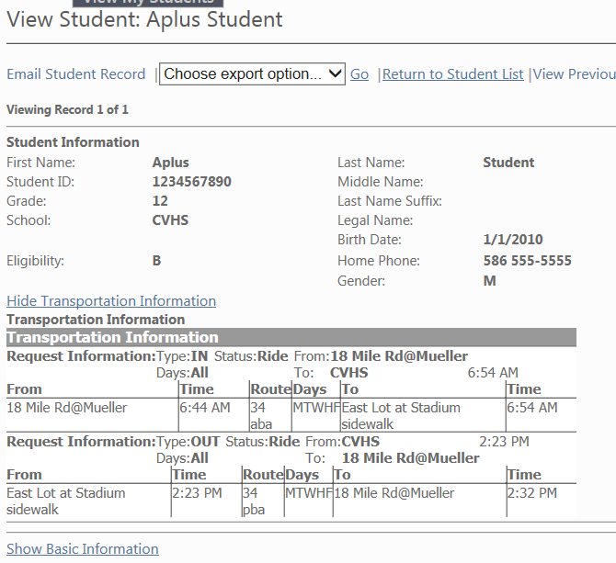
Bus Stop
Route #
Stop Time

